

A Project Report

On

“ATM SIMULATOR SYSTEM”

**BBA(CA)PAT.2019 – Semester V**

**Jog Educational Trust’s**

P.Jog College of Science and Commerce,

Mayur Colony,Kothrud,Pune – 411038

# Submitted by :

# Shubhankar Geeta Kashyap

# &

# Aniruddha Sanjay Bandal



CERTIFICATE

Certified that this is a Bonafied record of Project titled

“ATM SIMULATOR SYSTEM”

# This is to certify that Shubhankar Geeta Kashyap & Aniruddha Sanjay Bandal of BBA(CA)PAT.2019 SEM-V , have completed their Project Work Titled “ATM Simulator System” as a part of Curriculum , during the Academic year 2023 – 2024 .

# Head Of Department|(HOD) : Principal :

# Mrs.Vidya Domatwar Dr.P.B.Buchade

# Names of Examiners : Signature :

# 1.

# 2.

# Date :



GUIDE CERTIFICATE

# This is to certify that , Shubhankar Geeta Kashyap & Aniruddha Sanjay Bandal of BBA(CA)PAT.2019,SEM-V , have successfully completed their project titled “ATM Simulator System” , under my guidance.

# Project Guide :

# Mrs.Vidya Domatwar

# Date : Place :



DECLARATION

# To,Principal Sir,

# P.Jog College of Science and Commerce,

# Kothrud,Pune – 411038

# Respected Sir,

# We here by honestly declare that matter embodied in my project “ATM Simulator System” submitted by us at P.Jog College of Science and Commerce for award of Bachelor Of Business Administration (Computer Application)2019 Pattern SEM – V of Savitribai Phule Pune University(SPPU), has not been submitted elsewhere for award of any degree , during the academic session of 2023 – 2024 .

# Thank You .

# Yours Faithful :

# Shubhankar Geeta Kashyap

# Aniruddha Sanjay Bandal

# Date : Place :

ACKNOWLEDGEMENT

# We take this opportunity to express our sincere gratitude to all those who helped us in various capacities in undertaking this project and devising the report . We are privileged to express our sense of gratitude to our respected teachers ,whose unparalleled knowledge moral fiber and judgment along with their know-how , was immense support in completing the project .

# We are also grateful to Prof.Vidya Domtwar , the Head Of Department , for the brainwave and encouragement given . We take this opportunity also to thank our friends and contemporaries for their cooperation and compliance .

# Thank You .

# Shubhankar Geeta Kashyap

# &

# Aniruddha Sanjay Bandal

INDEX

|  |  |  |
| --- | --- | --- |
| Sr no . | TOPIC | Page no . |
| 1. | INTRODUCTION | 1 |
| 2. | AIMS & OBJECTIVES OF THE PROJECT | 2 |
| 3. | SOFTWARE & HARDWARE REQUIRMENTS | 3 |
| 4. | FEASIBILITY STUDY | 4 |
| 5. | FUTURE ENHANCEMENT | 5 |
| 6. | DATABASE & TABLES IN MYSQL | 6-8 |
| 7. | PROJECT SLIDES | 9-15 |
| 8. | DIAGRAMS | 16-19 |
| 9. | CONCLUSION | 20 |
| 10. | REFERENCES | 21 |

1.

INTRODUCTION

The Title of our project model is “ATM Simulator System”, the project is developed in JAVA language . “ATM Simulator System” project is model that enables the customer to perform the basic banking transactions by sitting at home or at their office through PC or Laptop. The system provides the customer the facility to first create an account in the bank if he is not the registered the customer of the bank.

For account creation of the customer his personal information is taken through three separate pages each regarding to separate types of user information, these details are then stored in the database. At the end of the account creation process, a unique account number and pin is created for every customer, pin can be changed later on.

If the user is already registered he can use his unique Account number and PIN to sign up into the ATM System to perform various actions, transactions and view Mini statements through the ATM.

The user can perform the transactions on account as per their requirement , but following are the transactions and actions which can be performed :

Deposit, Withdrawl, Fastcash, BalanceEnquiry, PinChange and generating Mini Statement .

2.

AIMS & OBJECTIVES

OF THE PROJECT

Aim of the Project :

The main of the project is to provide a module to banks which provides user a safe, efficient and easy to use ATM module for account creation and to perform various transactions and other actions.

Main Objectives :

1.Efficiency : Our motto is to develop a ATM Simulator System through which various Banking transactions like Deposit , Withdrawl , FastCash can be carried out in most efficient way possible, and also perform various other process like BalanceEnquiry , PinChange and Genarating MiniStatement in an efficient way .

2.User Satisfaction : User can do his operations comfortably without any risk to his privacy . Our software is also very easy to use and user friendly.

3.Protecting User data : To protect user information

4.Transacting Money : Help user perform various transaction like deposit,withdrawl etc.

3.

SOFTWARE & HARDWARE

REQUIREMENTS

1.Software Requirements :

* Operating System – Windows 11 is used as the operating system as it is stable, easy to use and supports more features.
* Database – MYSQL is used as database as it more easy to understand and maintain and retrieve records by simple queries which are in English language , making them easy to understand and easy to write .
* MYSQL Workbench – MYSQL Workbench is an software which provides an interface to run and execute MYSQL queries.
* NetBeans IDE – for writing code & executing them
* Language – JAVA
* Development tools – JDK 17.07 ,its an LTS(Long Term Support) version of Java Development Kit
* Lucid Application and Paint – to create Diagrams

2.Hardware Requirements :

* Processor – Intel core i3 10th generation processor , because its fast and highly reliable processor.
* RAM – RAM 8GB

4.

FEASIBILITY STUDY

# Technical feasibility :

The system is being developed in JAVA . It provides comprehensive function to make it user friendly. The data entry and report generation is also made easy. It also provides easy retrieval of data.

# Social feasibility :

As this system is user friendly and flexible some problems will also be solved which employee may be facing when using existing system. So we can say that system is socially feasible.

# Economical feasibility :

The cost of converting from manual system to new automatic computerized system is not probably more. For construction of the new system, the rooms and its facilities are available so it does not require any extra resource, only the software requirement is there.

# Operational feasibility :

Since the system is being in user friendly way, the new customer within a few time can master it.

5.

FUTURE ENHANCEMENT

The “ATM Simulator System”is a big and ambitious project. We are thankful for being provided this great opportunity to work on it. As already mentioned, this project has gone through extensive research work. On the basis of the research work, we have successfully designed and implemented banking online System. To know what the future looks like we have to look at the present and identify the faults in the system and to work on it .

The most valuable future looks are following below:

1. More branches of the bank, maybe it will be international, that means more ATM machines outside.
2. Customer issues development based on their needs, so the help desk will be aware of their needs and easy to use.

3-Email and Mobile number Verification

4-OTP for security

6.

DATABASE & TABLES

Databases-bankmanagementsystem

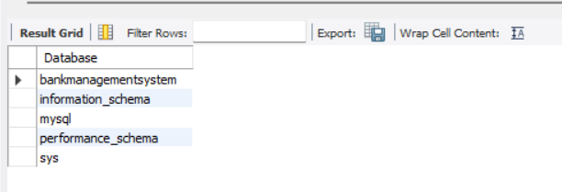

All tables in Database :

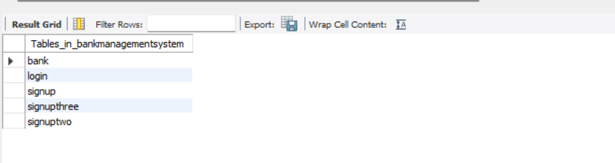

Bank table :

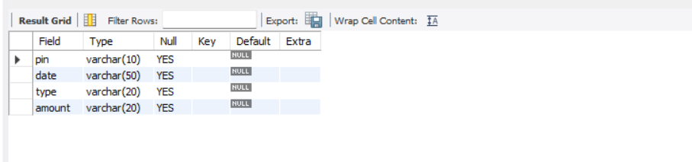

7.

Login table :

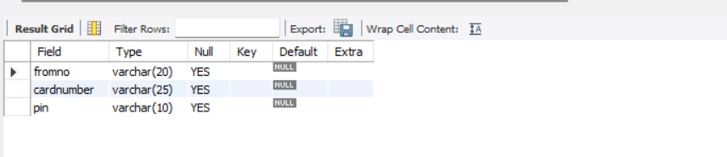

Signup table :

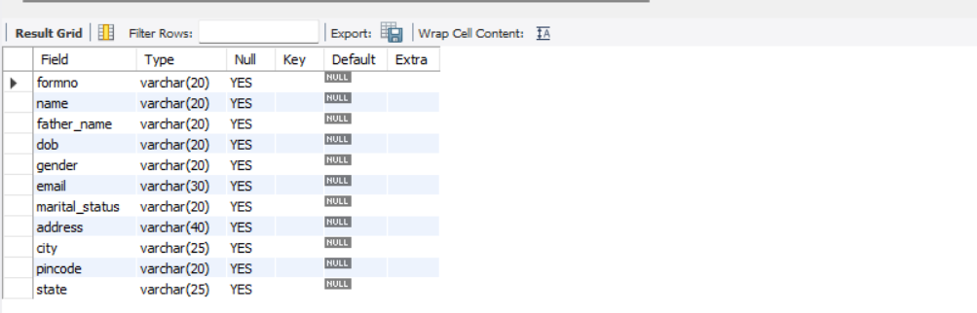

Signuptwo table :

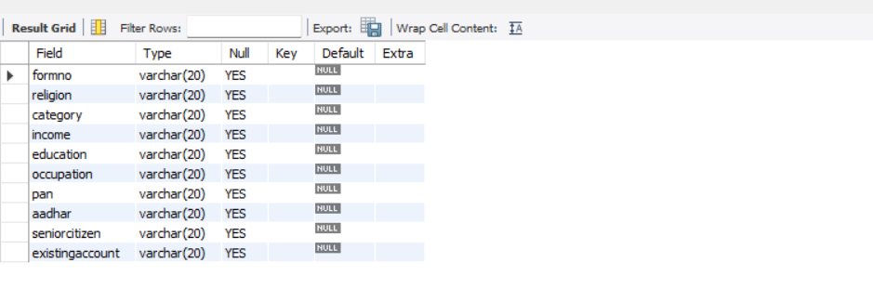

8.

Signupthree table :

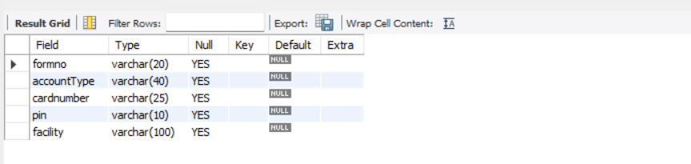

9.

PROJECT SLIDES

Login.java

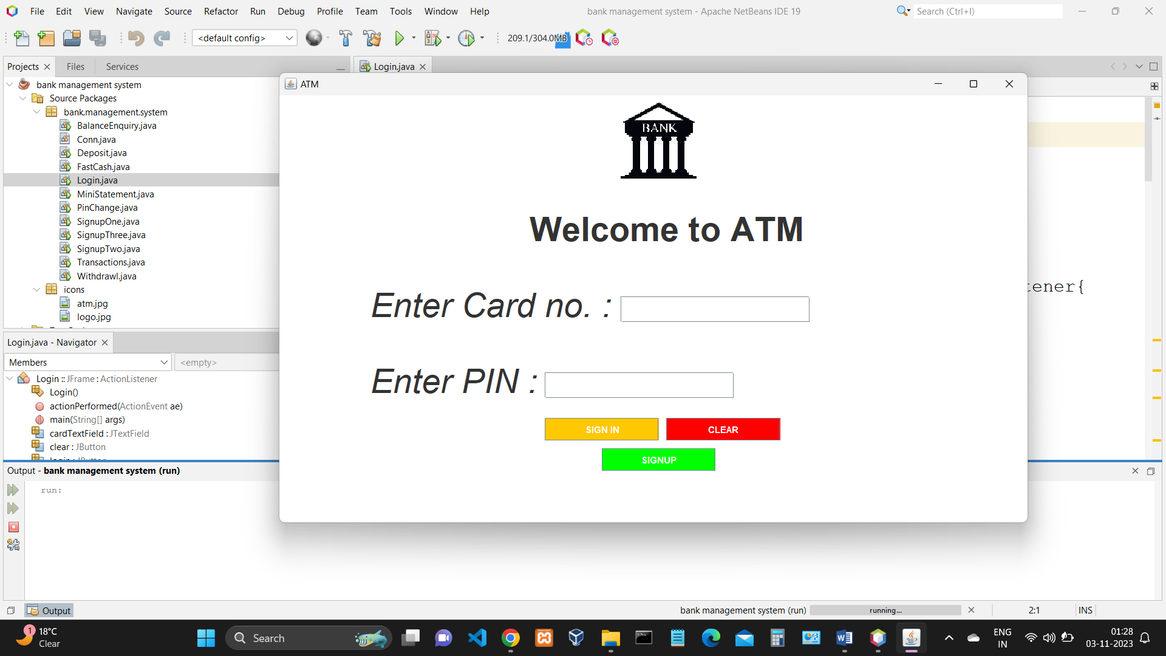

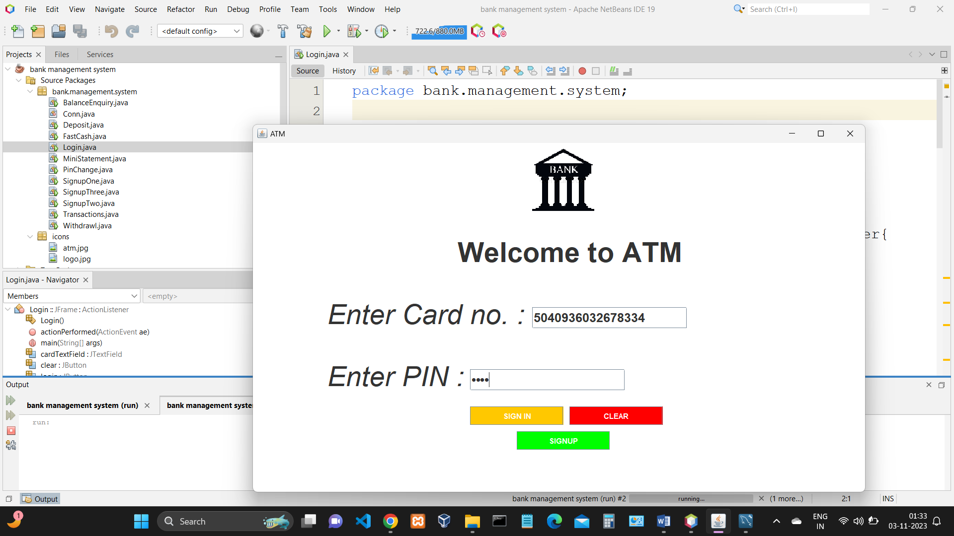

10.

SignupOne.java :

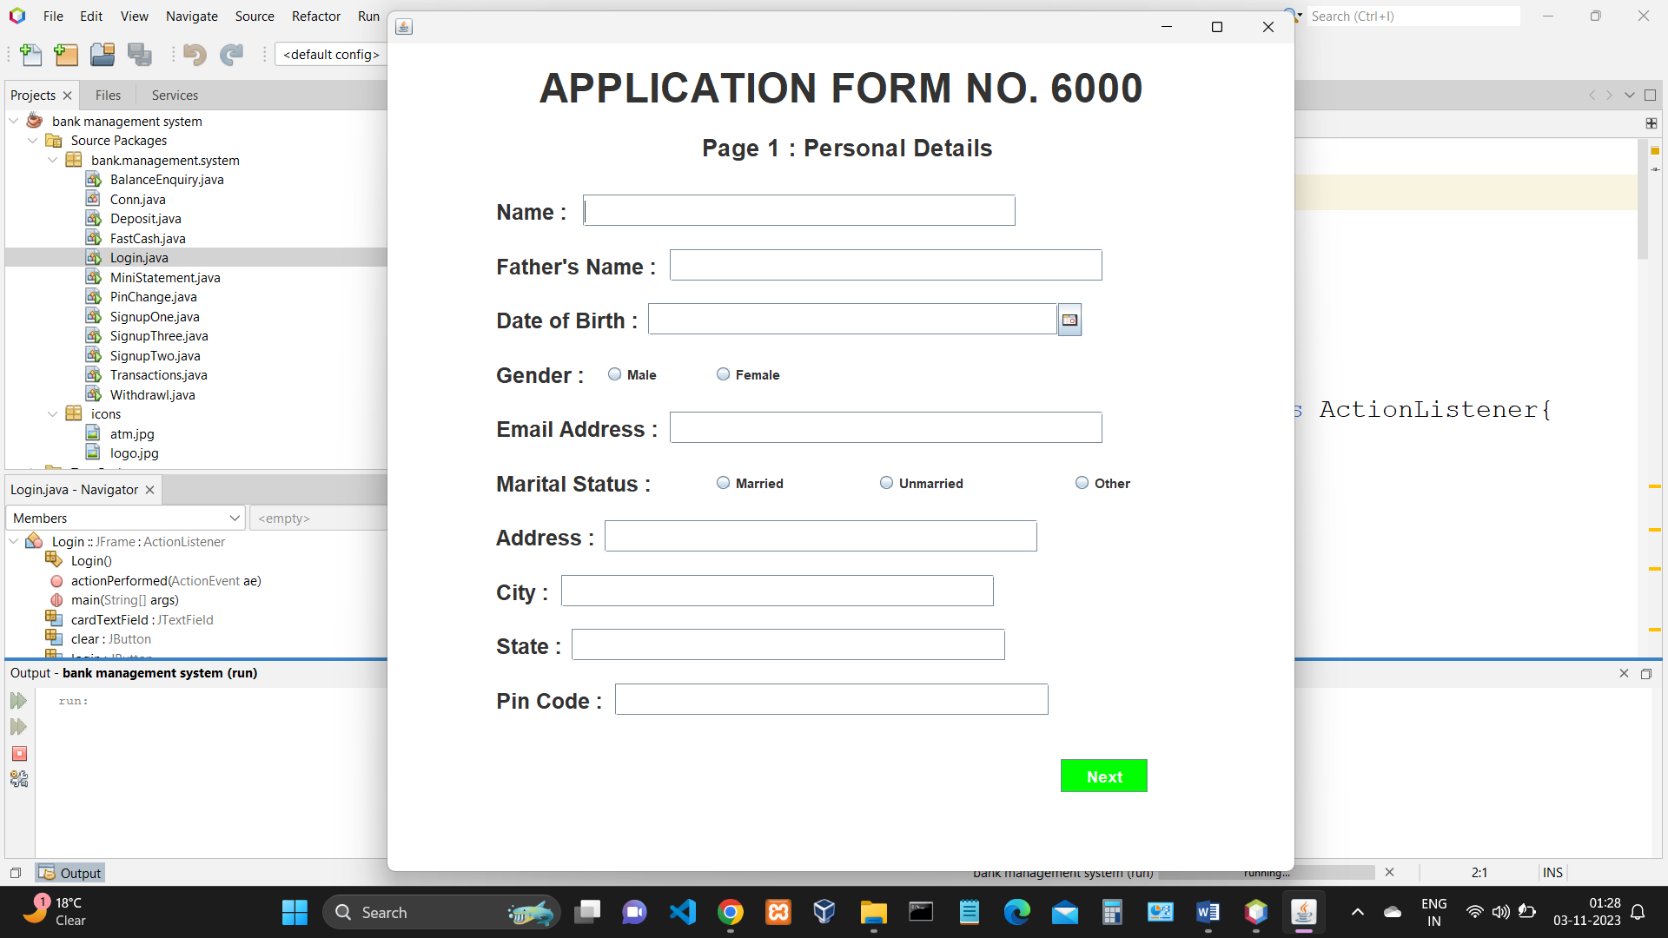

SignupTwo.java :

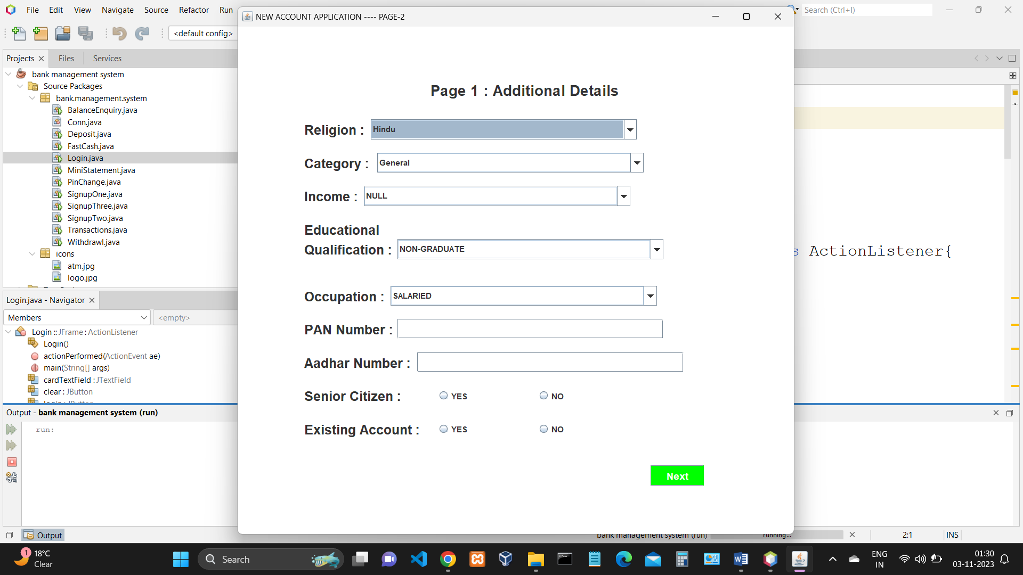

11.

SignupThree.java :

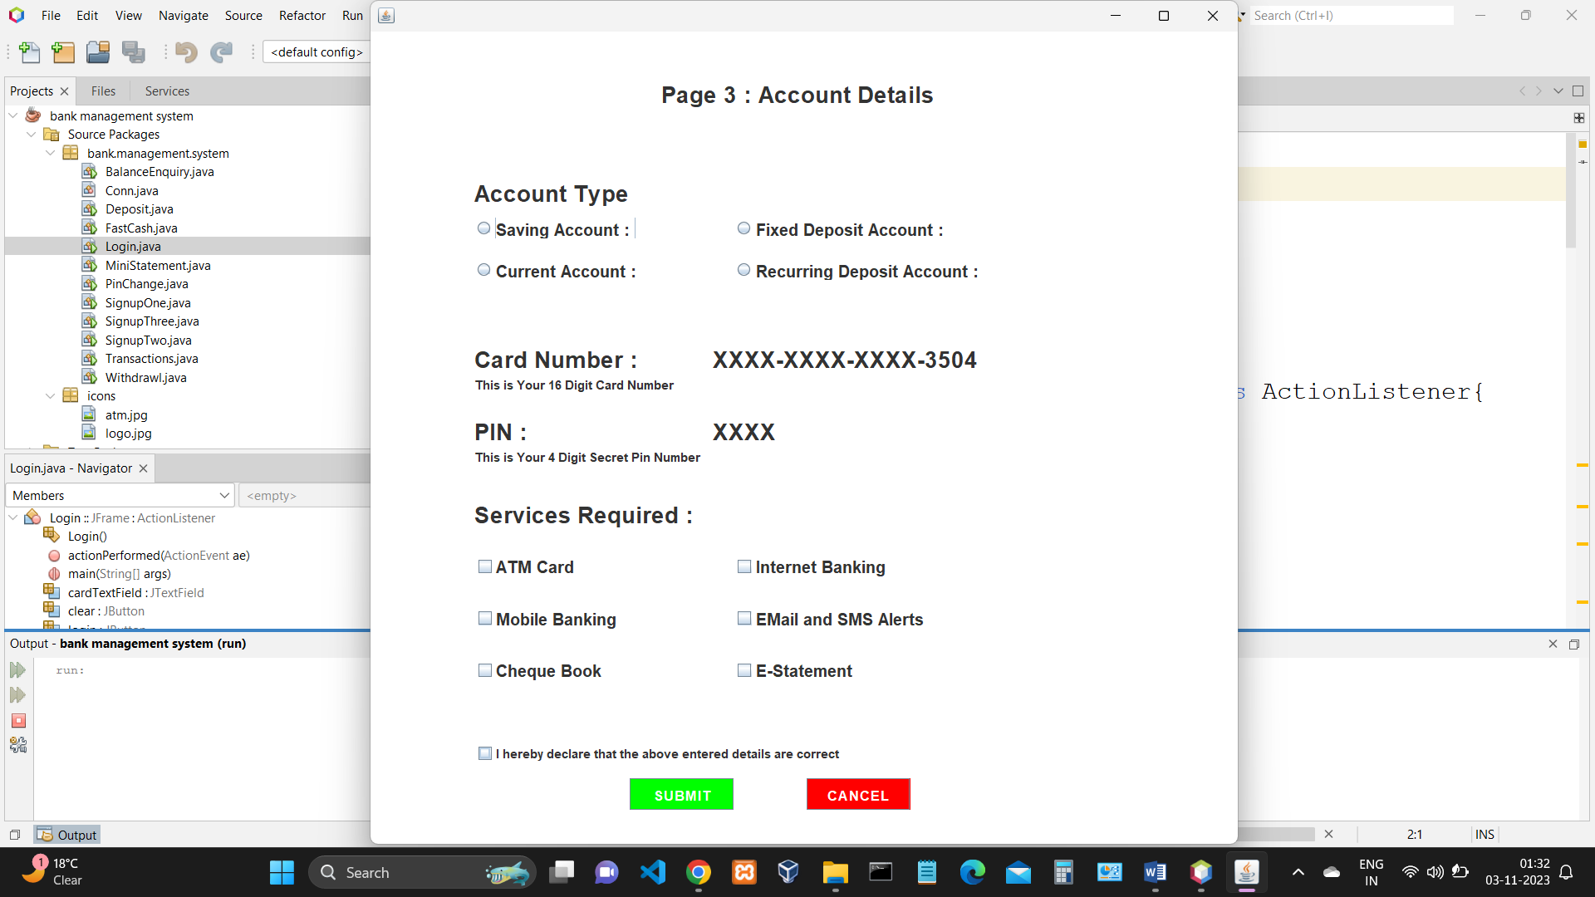

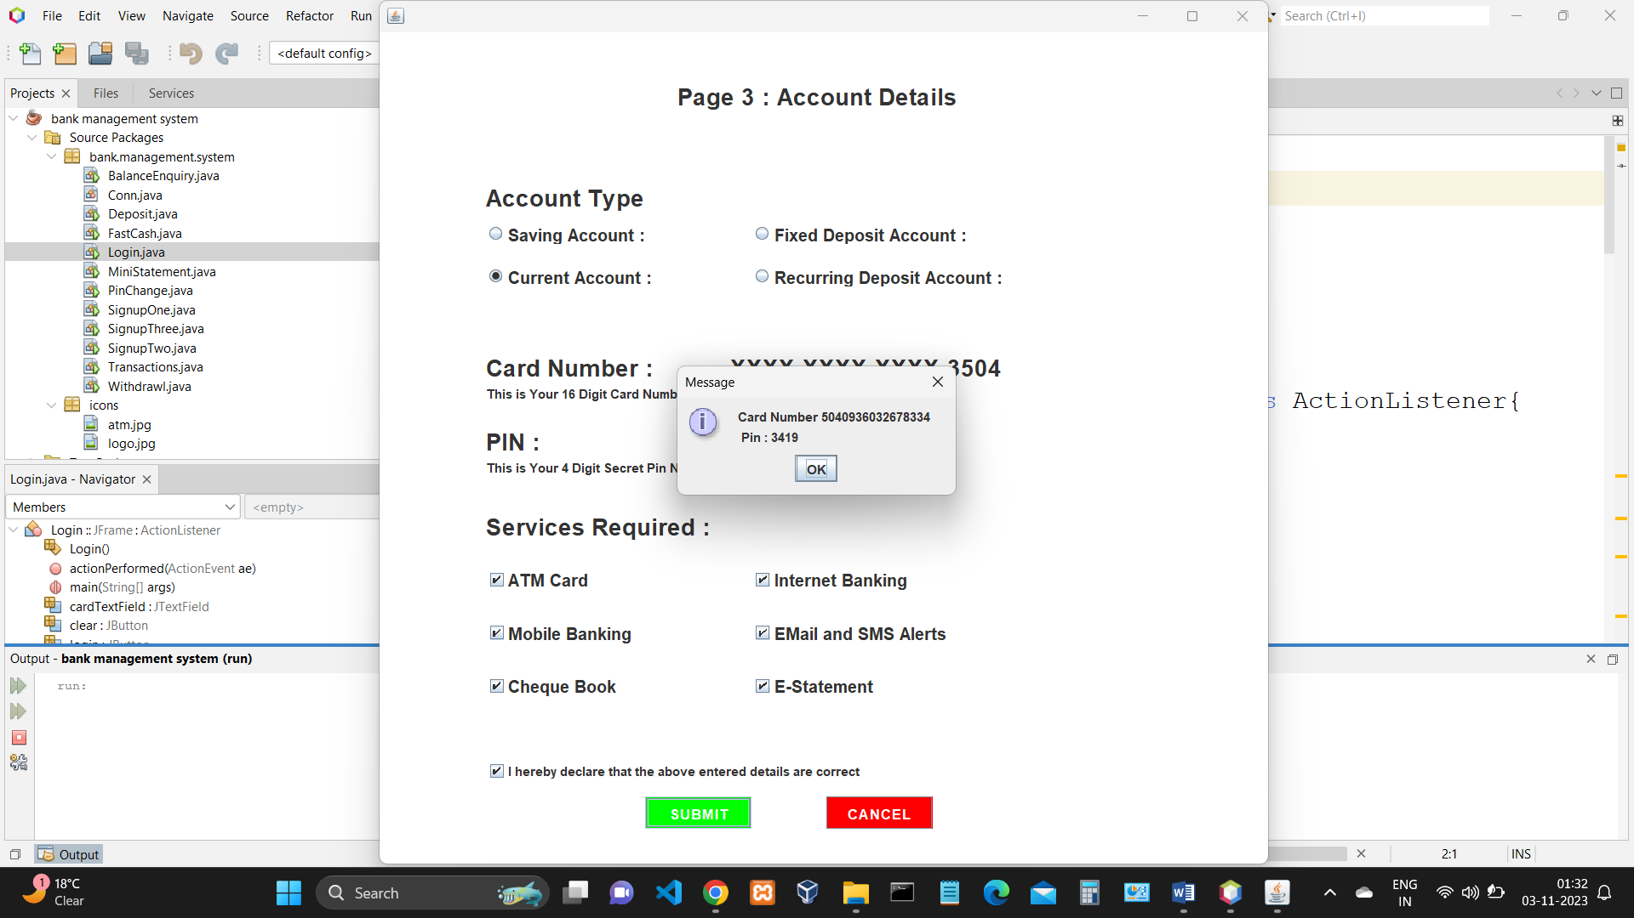

12.

Transactions.java :

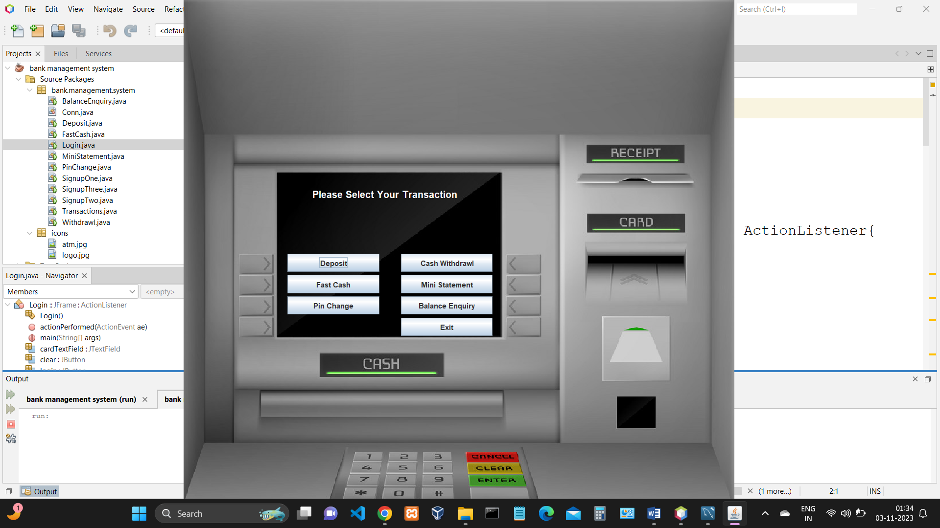

Deposit.java :

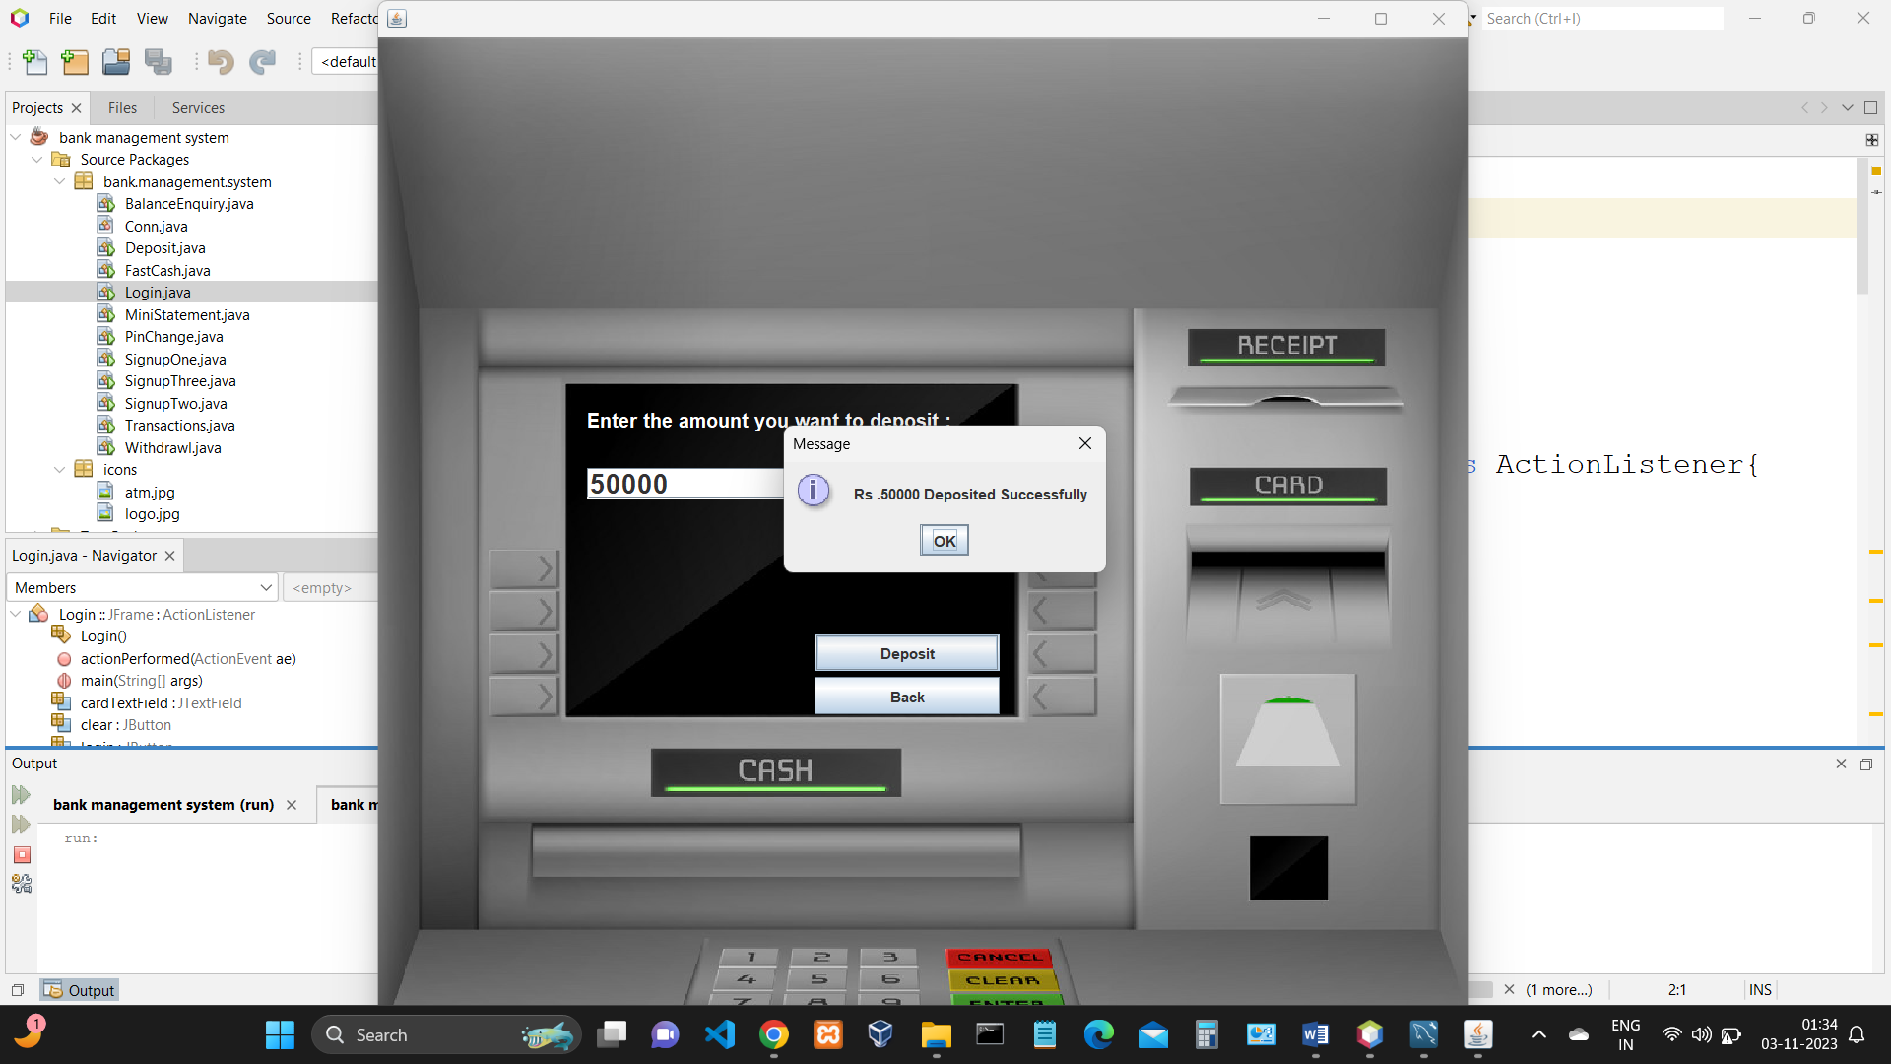

13.

Withdrawl.java :

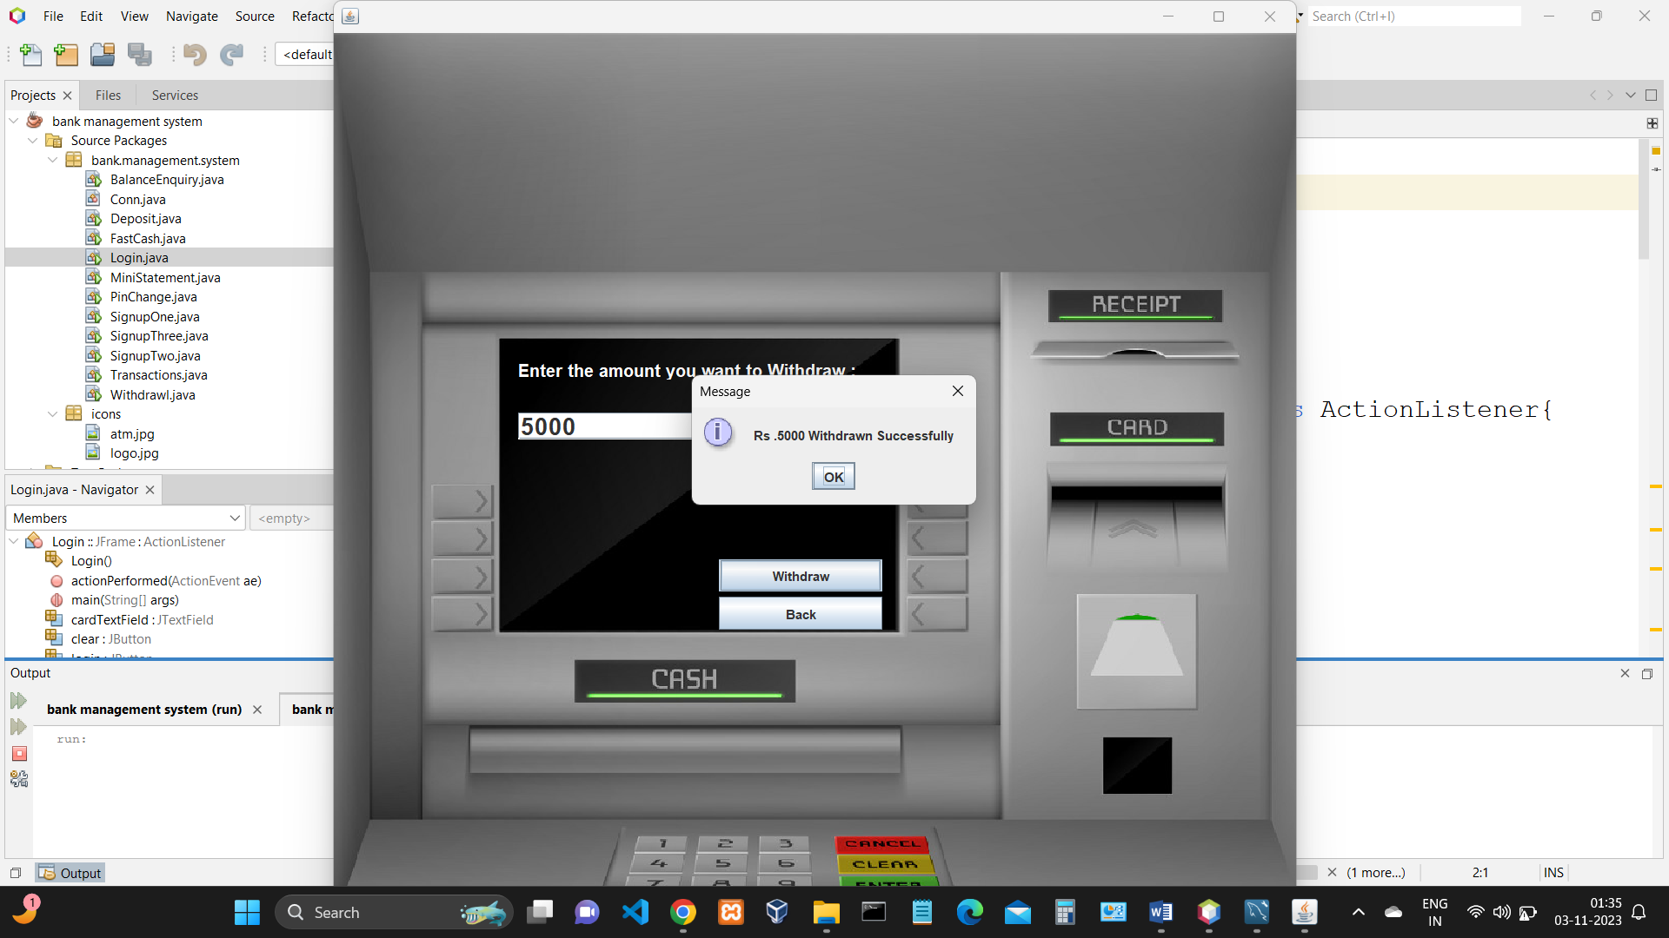

FastCash.java :

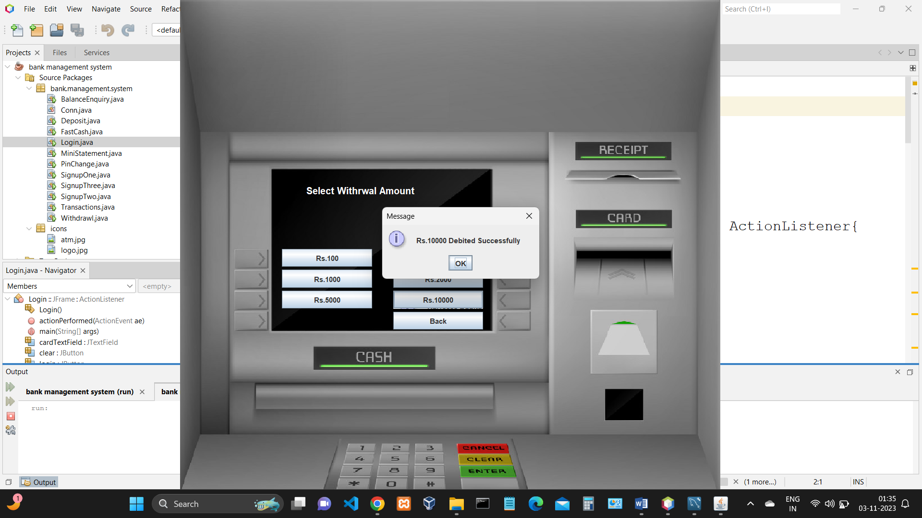

14.

BalanceEnquiry.java :

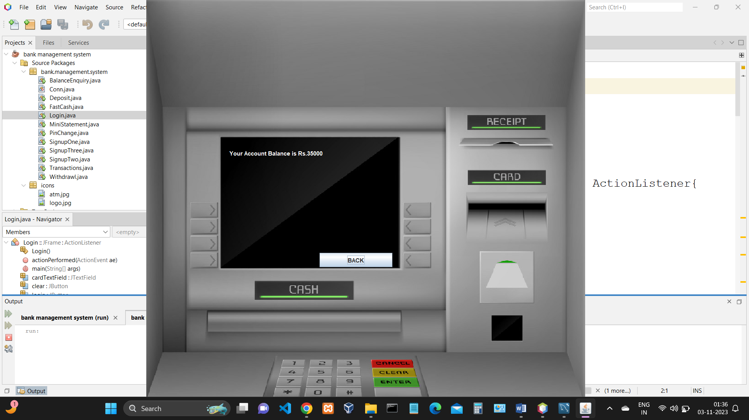

PinChange.java :

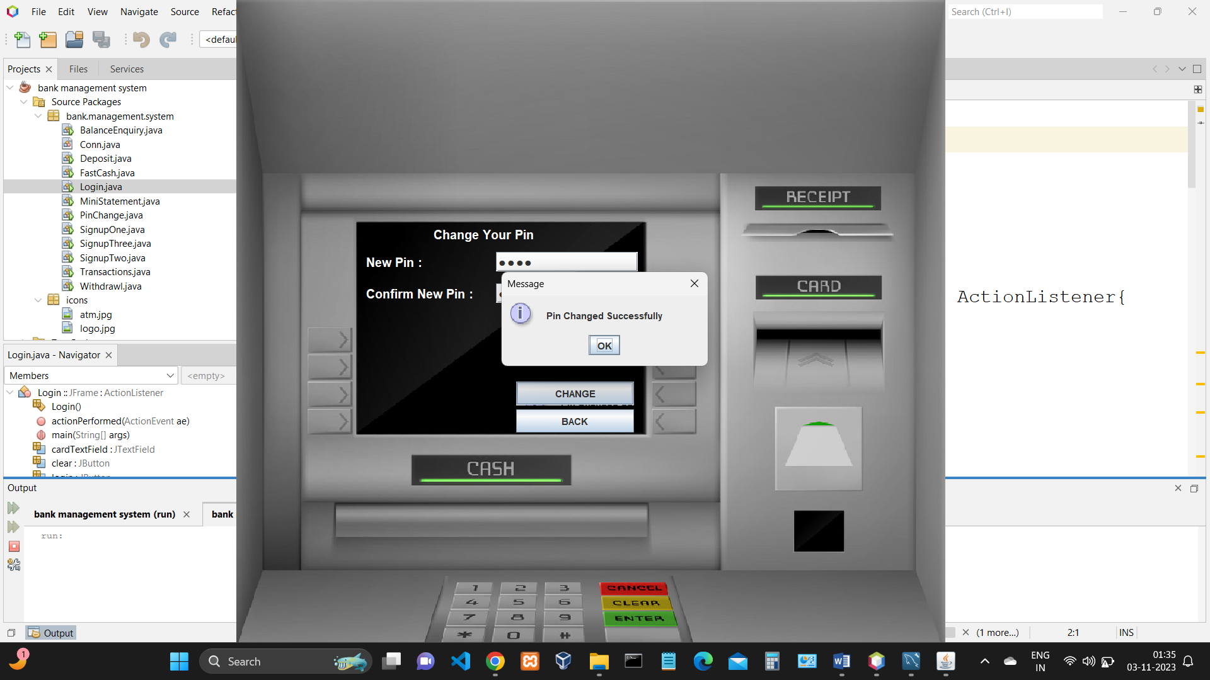

15.

MiniStatement.java :

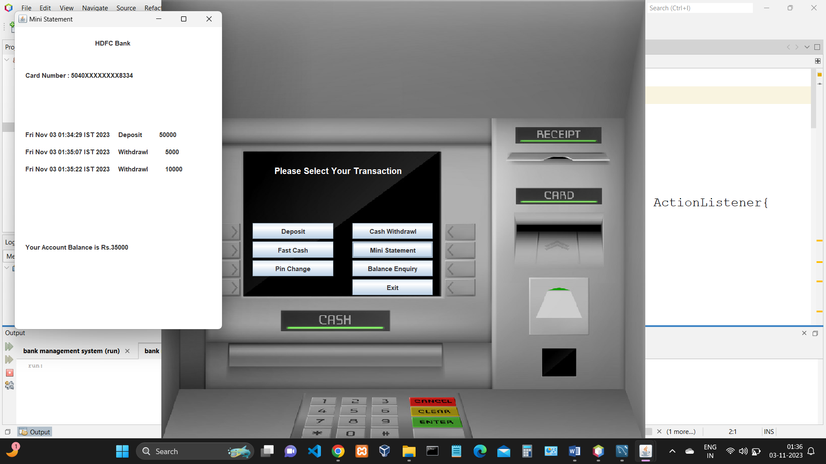

16.

DIAGRAMS

# 1.USECASE DIAGRAM :

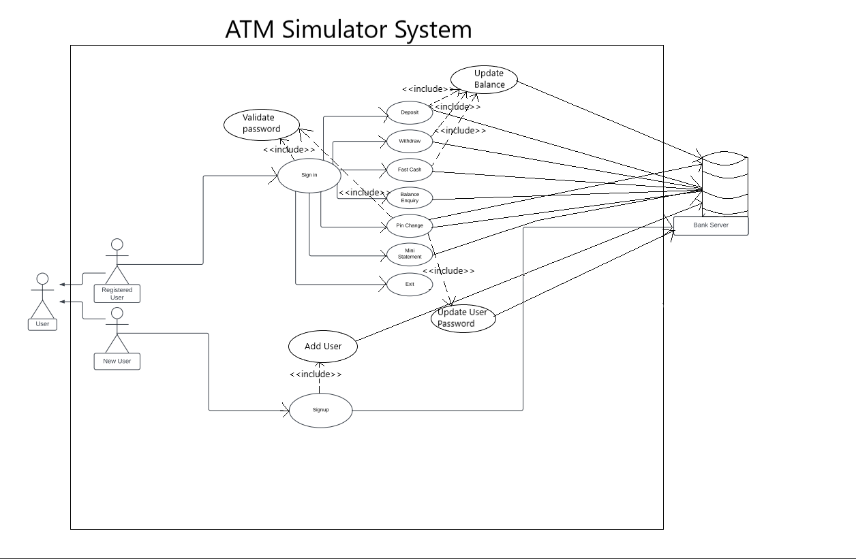

# 17.

# 2.CLASS DIAGRAM :

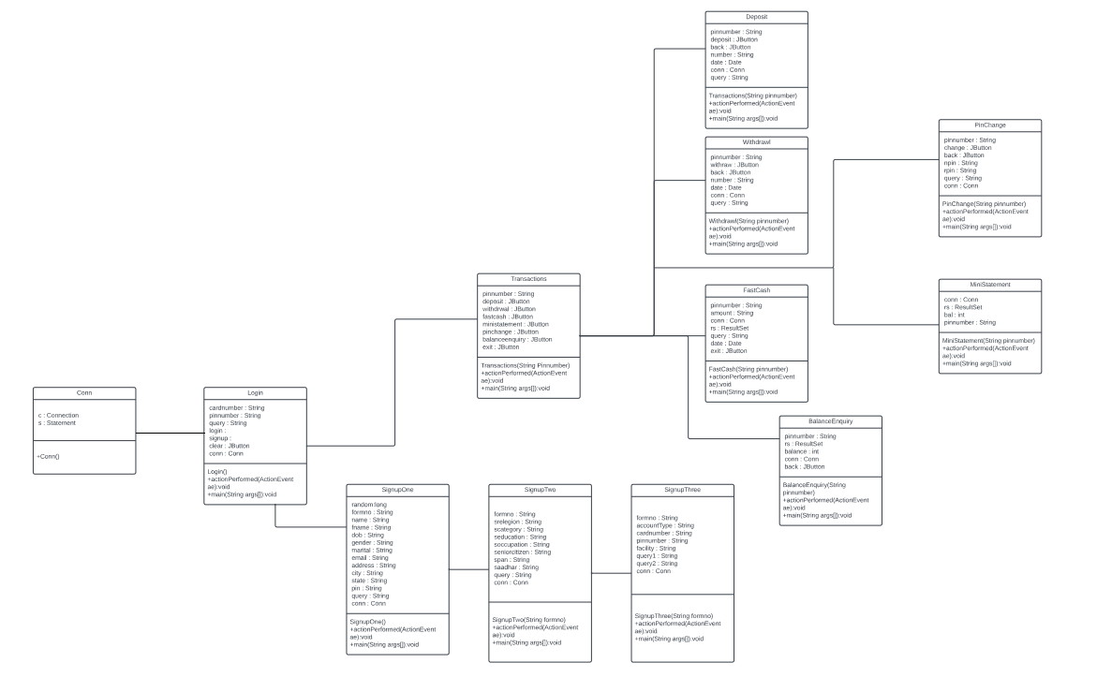

# 3.STATE - CHART DIAGRAM :

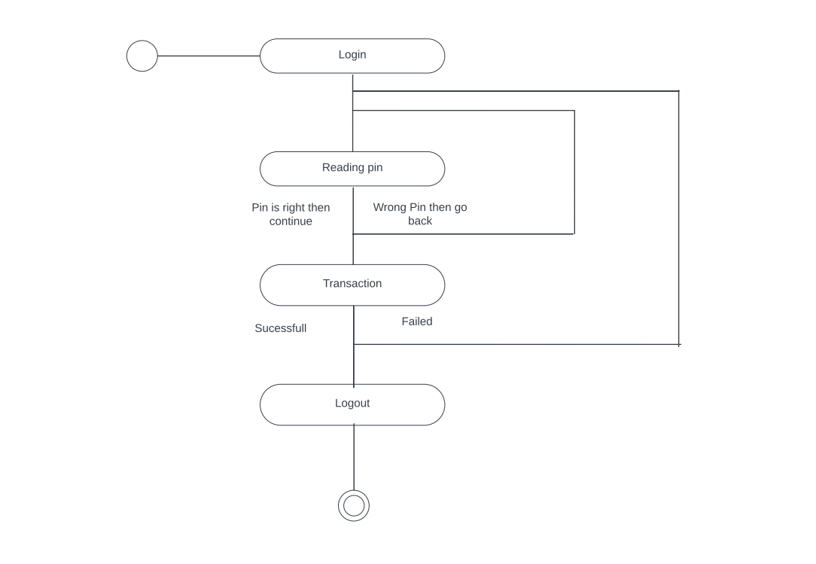

18.

# 4.SEQUENCE DIAGRAM :

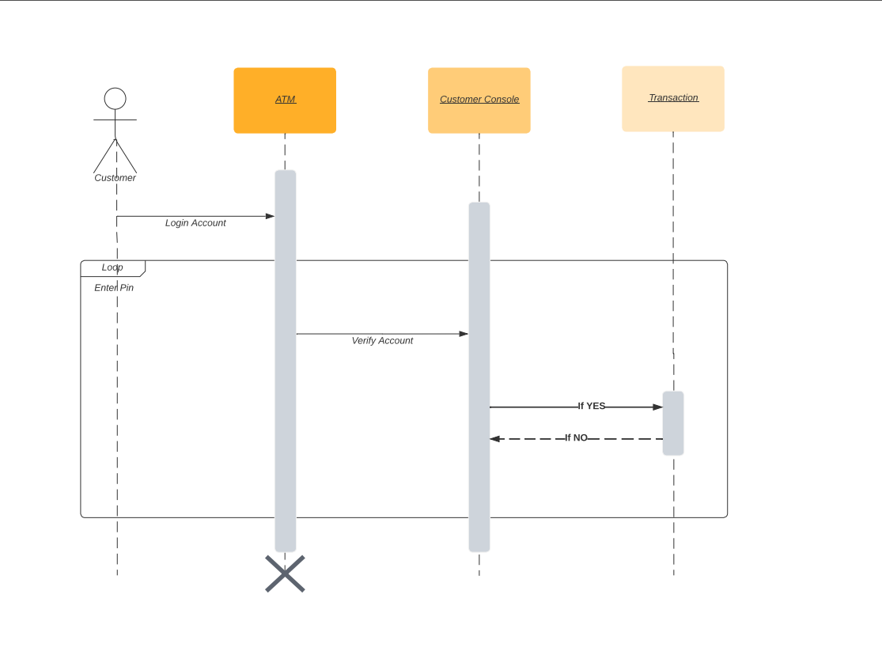

# 19.

# 5.ER DIAGRAM :

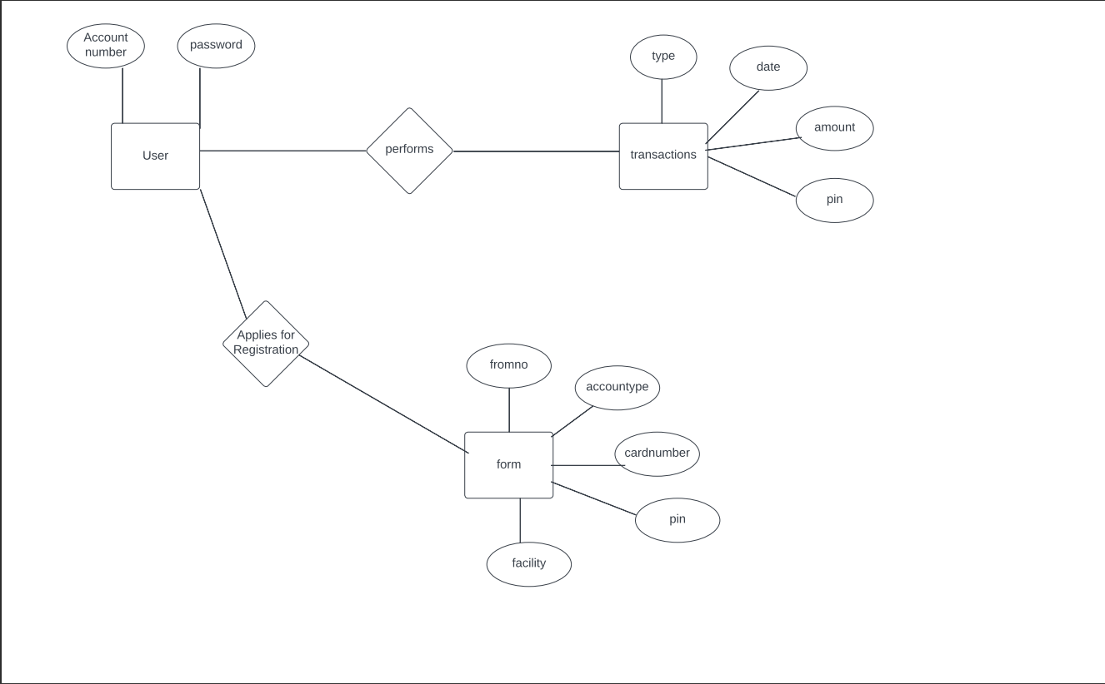

20.

CONCLUSION

This project is developed to nurture the needs of a user in a banking sector by embedding all the tasks of transactions taking place in a bank. Future version of this project will still be much enhanced than the current version. We can add email and Mobile Number verification through OTPs, all banks have rules about how long it takes to access your deposits, how many debit card transactions you're allowed in a day, and how much cash you can withdraw from an ATM. Access to the balance in your checking account can also be limited by businesses that place holds on your funds. We can set limits to how much can be money can be withdrawn and deposited and how many times a transactions can be performed above things will add to security of the ATM.

Thus, the Bank Management System it is developed and executed successfully.

21.

REFERENCES

# W3schools - https://www.w3schools.com/java/

* JavaTpoint - <https://www.javatpoint.com/>
* GeeksforGeeks - https://www.geeksforgeeks.org/java/